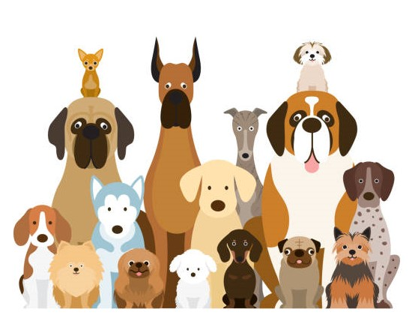
TOWN OF PERU DOG LICENSE REGISTRATION APPLICATION

Town Clerk Office Phone# 413-655-8312 Ext 102
E-mail: townclerk@townofperuma.com

To Obtain Dog Licenses by mail, Complete a Dog License Registration Form & Enclose the Following:
A Check Payable To “Town of Peru”, Copy of Current Rabies Vaccination Cert if one is not on file in the clerk's office and Self-Addressed Stamped Envelope; if any of these items aren't included with your purchase the dog license will not be mailed out , you will need to provide the missing item/items and pick up the license in person at the town clerk office.
MAIL TO: Town of Peru, Town Clerk, 3 East Main Rd, Suite 102, Peru MA 01235
DROP Off: Town Clerk Drop Box located to the right of the Town Hall front door
Residents can now pay for their Dog Licenses online with UniPay by UniBank Go to https://www.townofperuma.com/ On the main page of the Town website, Click Town Clerk Office Online Payment Center under Town Resource Center or go to the Town’s Clerk’s page.
Dog Licenses are a one-year license and go from April 1st -March 31st of each year. A $10.00 Late Fee Applies after March 31st

Owner’s Name: ________________________________________________________________________________________Date____________________________________________
Address: _______________________________________________________________________________________________Phone ___________________________________________
1st Dog New ______________ Renewal ______________ Late Fee $ 10.00 (applies after 3/31) ______________________________
Male $15.00 ______________ Female $15.00 ______________ Neutered Male $10.00 ______________ Spayed Female $10.00 ______________
Name of Dog_____________________________________________ Breed______________________________ Color ______________________________ Age_______________
2nd Dog New ______________ Renewal ______________ Late Fee $ 10.00 (applies after 3/31) ______________________________
Male $15.00 ______________ Female $15.00 ______________ Neutered Male $10.00 ______________ Spayed Female $10.00 ______________
Name of Dog_____________________________________________ Breed______________________________ Color ______________________________ Age_______________
3rd Dog New ______________ Renewal ______________ Late Fee $ 10.00 (applies after 3/31) ______________________________
Male $15.00 ______________ Female $15.00 ______________ Neutered Male $10.00 ______________ Spayed Female $10.00 ______________
Name of Dog_____________________________________________ Breed______________________________ Color ______________________________ Age_______________

For a Multi-dog License (4-6 dogs) $35.00
4th Dog New ______________ Renewal ______________ Late Fee $ 10.00 (applies after 3/31) ______________________________
Male $15.00 ______________ Female $15.00 ______________ Neutered Male $10.00 ______________ Spayed Female $10.00 ______________
Name of Dog_____________________________________________ Breed______________________________ Color ______________________________ Age_______________
5th Dog New ______________ Renewal ______________ Late Fee $ 10.00 (applies after 3/31) _______________________________
Male $15.00 ______________ Female $15.00 ______________ Neutered Male $10.00 ______________ Spayed Female $10.00 ______________
Name of Dog_____________________________________________ Breed______________________________ Color ______________________________ Age_______________
6th Dog New ______________ Renewal ______________ Late Fee $ 10.00 (applies after 3/31) _______________________________
Male $15.00 ______________ Female $15.00 ______________ Neutered Male $10.00 ______________ Spayed Female $10.00 ______________
Name of Dog_____________________________________________ Breed______________________________ Color ______________________________ Age_______________
Kennel Licenses (For 7 or more dogs $110.00) contact the Town Clerk Office
$50.00 Fine for Failure to License Mass General Laws Chapter 140 Sec 141

Article 19. ANIMAL CONTROL PERU BY-LAW
2: DOGS REQUIRED TO BE LEASHED
A. No owner or keeper of a dog shall permit such dog, whether licensed or unlicensed to run-at-large within the Town of Peru. No person shall permit a dog owned or kept by him beyond the confines of the property of the owner or keeper unless the dog is physically restrained by a leash.
B. No person shall permit a dog owned or kept by him to run freely within the confines of the property of the owner or keeper unless leashed so as to restrain the dog in such manner that the dog will not go beyond the property of the owner or keeper, or unless the dog is securely confined to the premises by the owner or keeper by fencing or appropriate barriers., or unless the dog is under direct voice control of the owner or keeper.
C. This action shall not apply to property owned and/or controlled by the Commonwealth of Massachusetts where a separate set of rules and regulations apply.
D. A dog my for the purpose of events such as working, hunting, field trails or training purposes be exempt for the restraining order during such period of time as the dog is actually engaged in the event or sport, provided the dog is under the direct supervision of a person of adequate age and discretion to properly control its actions.
Section 3: LICENSE REQUIREMENTS, FEES, EXCEPTIONS
A. Any owner or keeper of a dog (6) six months of age or older in the Town of Peru shall cause the dog to be licensed as required by the MGL., Chapter 140 commencing on January 1st of each year.
B. Any owner or keeper of more than three dogs must acquire a multiple pet permit.
C. Each multiple pet household and commercial kennel shall be available to inspection by the Animal Control Officer, a Natural Resource Officer, Fish and Game Warden, Police Officer, or the Board of Health.
D. All dogs and cats (6) six months of age or older must be currently vaccinated against
rabies as per MGL., Chapter 140, Section 145B.
E. The annual fee for every animal license, multiple permit, and commercial kennel license and all fines relevant to animal control shall be established by the Board of Selectmen. No fee shall be charged for a license for a dog specifically trained to lead or serve a blind or deaf person provided that the division of the Blind or Deaf certifies that such dog is so trained and actually in the service of a blind or deaf person.
F. The registering, numbering, describing and licensing of animals shall be performed in the Office of the Town Clerk on a form prescribed by the Town, and shall be subject to the condition expressed therein that the dog so licensed shall be controlled and restrained from killing, chasing or harassing livestock or fowls.
G. No license fee shall be refunded in whole or in part for any reason.
H. Should any owner or keeper of an animal fail to license that animal as required by MGL., Chapter 140 before April 1, the owner or keeper shall pay a late fee as established by the Board of Selectmen before obtaining said license, except a dog brought into the Town as provided by MGL., Chapter 140 Section 138. This late fee shall be applicable from the 61st day after arrival of such dog. Any person maintaining a commercial kennel in the Town of Peru who fails to license as prescribed by this section and the laws of the Commonwealth, shall pay a late fee as established by the Board of Selectmen, commencing April 1st.
I. The owner or keeper of a licensed animal shall cause it to wear around its neck or body a collar or harness to which shall be securely attached a tag issued by the Town Clerk at the time of licensing.
J. In addition to all other sums due and owing for any license fee hereunder, a person for license hereunder shall be obligated to pay all prior amount of license fees determined to be due and owning by the Town Clerk pursuant to this By-Law, for past periods in which said person was obligated to obtain license. It shall be a violation of the By-Law, to fail to pay any said sum due hereunder; this remedy shall be cumulative.
Section 4: RESTRICTIONS ON NUMBER OF DOGS
No more than (6) six dogs may be kept at any private residence. Persons owning more than (6)
six dogs prior to the passage of this By-Law are permitted to keep such dogs, but may not
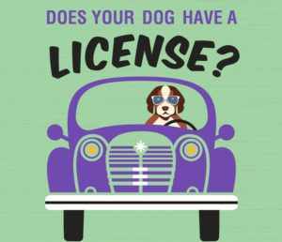
replace them in excess of the permitted total. This section shall not be applicable to dogs under
the age of (6) six months.
There is no charge for dog owners Age 70 years or older

